Program 23

Write a program to obtain a sList from user and then display its average?

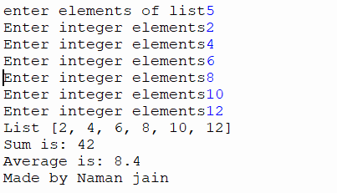

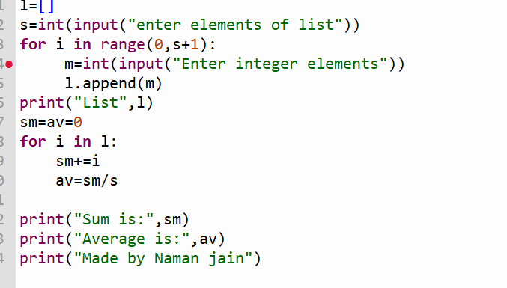

Program 24

Write a program to input a list from the user and then calculate total number of even ,odd and special charcters number from the list?

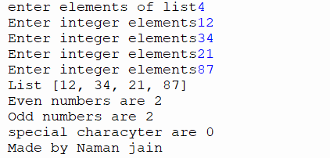

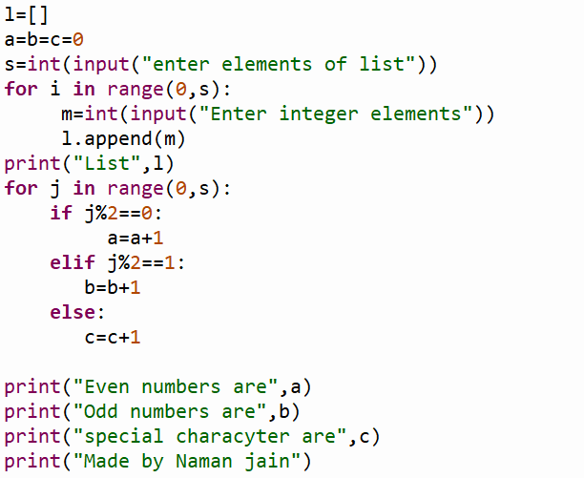

Program 25

Write a program to take input a list from the user and then calculate the repition of an element from the list?

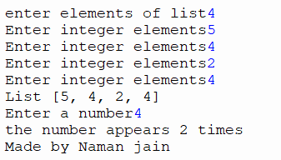

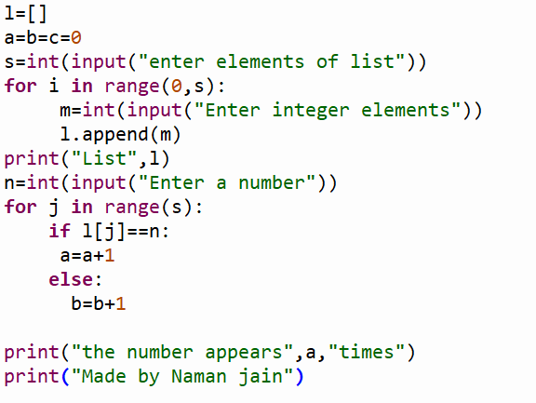

Program 26

Write a program to take input from the user and then add a element at desired index value?

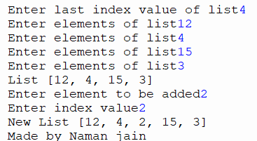

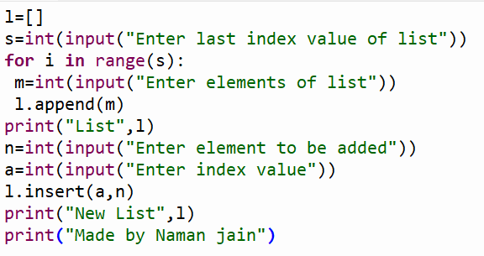

Program 27

Write a program to obtain a list from the user and then multiply all the elements of list ?

